Test Automation framework used for Gurukula App testing is Data driven Framework.

* There are 2 sets of file in the project – main and test
  + Main file consists of login details and methods, which are used to navigate through entities in the webpage.
  + App.java file has all the initialization methods, right from calling the driver to check login page and actual login.
  + Each set of navigation is mentioned under a specific function i.e. for example for Creating a branch there are set of entities which needs to be added with data and a button click is required to create.
  + There are 11 function sets in the testmethods.java file
    - Entityclick
    - Branchclick
    - Branchcreate
    - Branchsearch
    - Branchedit
    - Branchdelete
    - Staffcheck
    - Staffcreate
    - Staffsearch
    - Staffedit
    - Staffdelete
  + For Branch Edit and Branch Delete the approach is similar, search the entered branch (created earlier) and modify it/ delete it. Same is followed in staff edit and staff delete.
  + Assertions – Except for Login page, there are no parameters, entities which project the functionality have been correctly working or not. So, for the same reason I have implemented functional set in try catch block along with Assertion

**try** {

Assert.*assertTrue*(**true**, "Test case passed");

} **catch** (Exception e) {

Assert.*assertTrue*(**false**, "Test case failed");

e.printStackTrace();

}

* + Registration process is not covered as part of Automation testing (registration process is extensively covered in manual testing) as the registration is not happening and only 1 user details can be used in the application
  + Gurukulatestcases.java file extends App.java file and in App.java file every function will be called under initialize class under with the annotation - @org.testng.annotations.BeforeClass
    - This eliminates the calling of the initial functions in the test file.
  + @org.testng.annotations.Test
    - TestNG Annotations are used in this project, all the methods are called under this annotation
  + Data cleanup is also taken care of with this method
  + 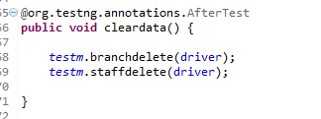
  + Similar to Initialization function, there is an end process function which closes the driver and the test will be completed.
  + 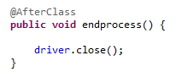

How to launch the tests is covered in the file called ***Teststeps.docx.***

Test cases, issues observed and pass/fail details are covered in ***gurukula_Functional.xlsx***